Dear all Bioschemas community members,

I am very proud to let you know that [map2model](https://github.com/BioSchemas/map2model#bioschemasorg-map2model) is available for bioschemas community use. This Python module, facilitates [Bioschemas Groups](http://bioschemas.org/groups/) in the specification definition process, defines steps to follow to: define a new bioschemas specification, update it’s content and share them to the community. Specifications GitHub Repository, which is integrated to map2model, simplifies the comments/issues administration, linking github issue tracking tools.

map2model integrates: Google Drive Specifications mappings, github Bioschemas repositories and Bioschemas Web page.

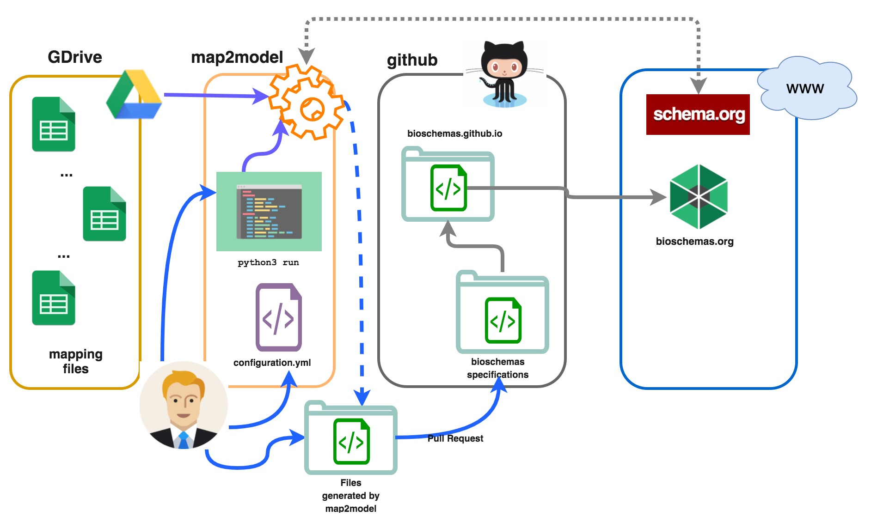

map2model retrieves properties and Bioschemas fields (Marginality, Cardinality and Controlled Vocabularies) from Bioschemas mapping files (in [GDrive](https://drive.google.com/drive/folders/0Bw_p-HKWUjHoNThZOWNKbGhOODg?usp=sharing)), then classifies properties into two groups:

1. Extended properties: Properties that are part of the extended [schema.org](http://schema.org/) Type.
2. New properties: Properties that are new to the [schema.org](http://schema.org/) vocabulary or are completely new to [schema.org](http://schema.org/).

After classifying the properties, map2model generates a Markdown file that can be interpreted by Bioschemas.org's web site thereby updating the Bioschemas.org web pages.

With map2model, we can integrate the steps: use case definition, mapping file generation, and specification publication in the Bioschemas Community, documentation explaining each of this steps is in the [specifications repository](https://github.com/BioSchemas/specifications#bioschemas-specifications-repository).

The files generated by map2model are the raw data for [bioschemas.org](http://bioschemas.org/) to build up human readable pages, in the following screenshots are some results of map2model:

All [Types/Specifications](http://bioschemas.org/newSpecs/)  list

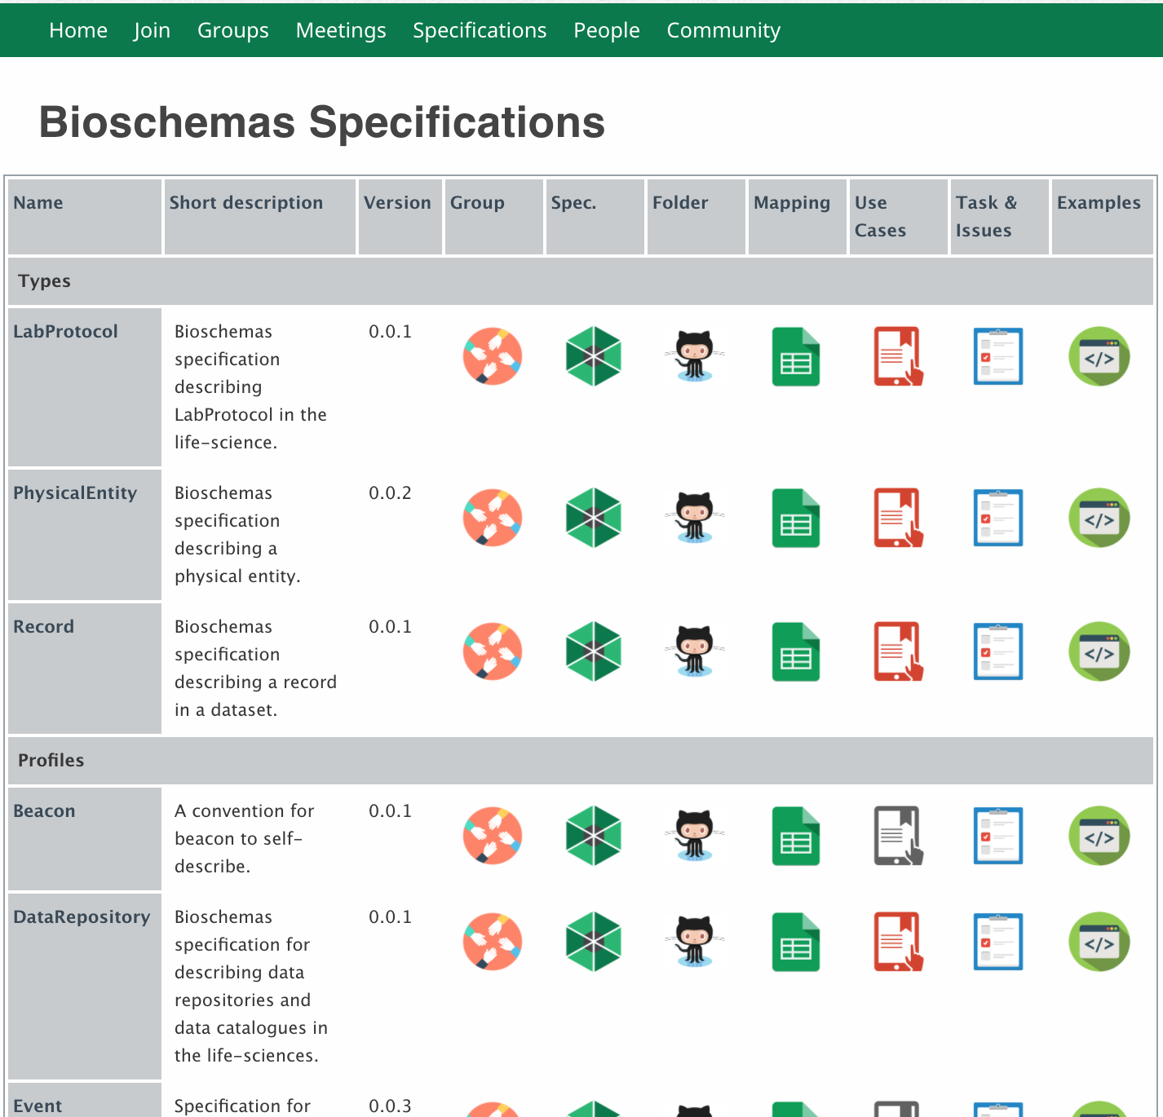

Type detail (same [schema.org](http://schema.org/) structure)

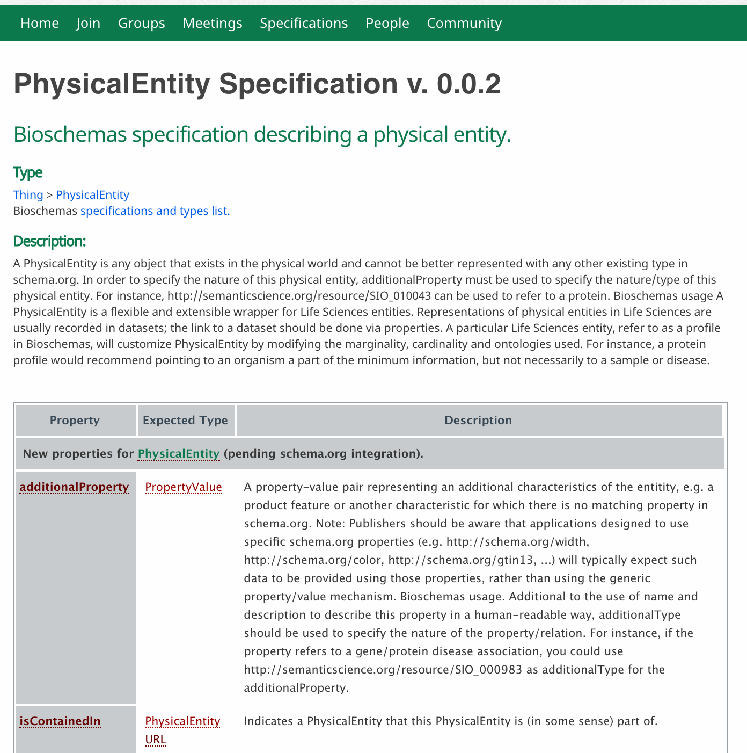

Specification detail (shows important information to users that like to annotated with Bioschemas types/profiles)

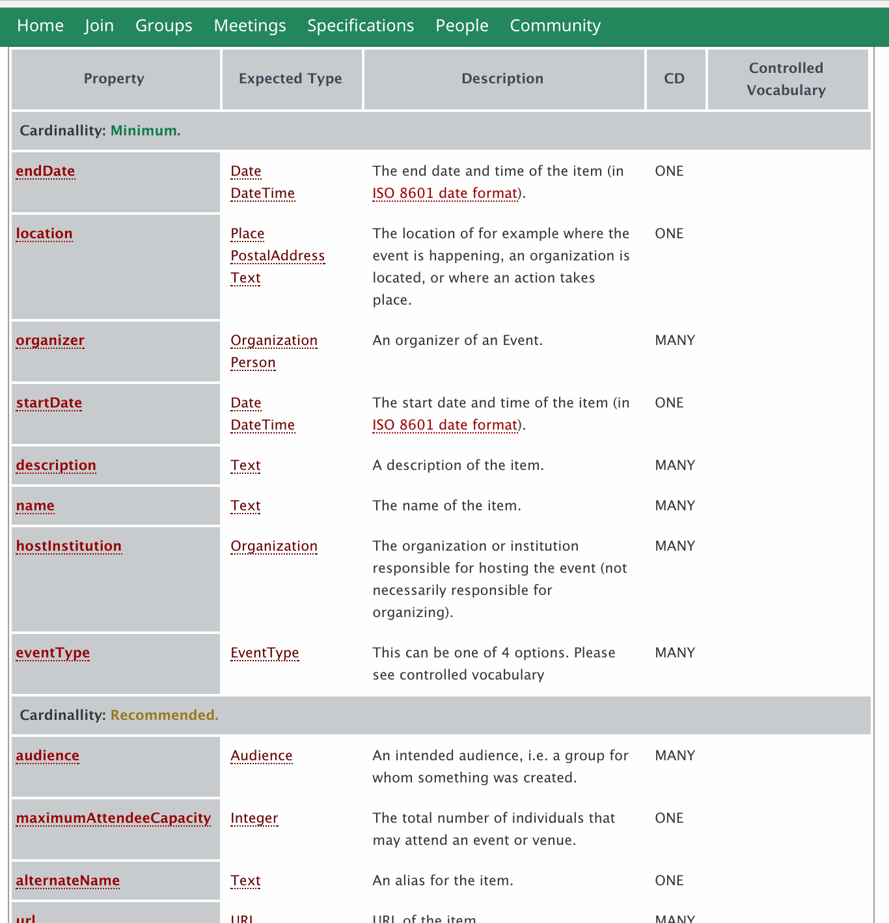

Please feel free to make a fork or a clone of map2model and start using in your BIoschemas participacion. I will be very happy to receive your feedback , and if it's needed make changes in the code, or clarify issues by the [github issue tracker](https://github.com/BioSchemas/map2model/issues), hope to have news about you by this means.

All the best,

Guillermo